Chili Cook Off ~ AA Speaker

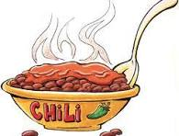

When: February 18th  12pm-3pm

Where: 2617 Club 1578 Strongs Ave

Stevens Point, WI

Join in on the fun, make and or have some Chili! We will eat from 12:00 – 1:00 p.m.

There is a signup sheet for Chili at the club, Toppings and can’t forget dessert.

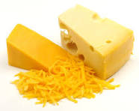

1:30 AA speaker from Eau Claire Wi

Nicholas S.

(Area 74 Delegate)

