**12 TRADITIONS**



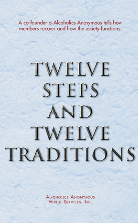

**WORKSHOP!!!**

**HOST:** A.A. DISTRICT 04

**SPEAKERS:** BILL AND JOANNE N., FROM TEXAS

**WHEN:** SATURDAY APRIL 26, 2025, 9:00AM- 4:30PM

**WHERE:** 2617 CLUB, 1578 STRONGS AVE.,

STEVENS POINT, WI 54481

(SOUTH ENTRANCE, DOWNSTAIRS)

**COME AND PARTICIPATE IN A DEEP-DIVE INTO OUR TRADITIONS WITH BILL AND JOANNE. OUR HOSTS HAVE MUCH EXPERIENCE AND INSIGHT INTO OUR TRADITIONS.**

**LUNCH, COFFEE, SODA AND BOTTLED WATER TO BE PROVIDED ON SITE.**

**THE WORKSHOP IS ALSO AVAILABLE BY ZOOM, COURTESY OF AREA 74.**

**MEETING ID: 479-428-9816 - PASSWORD: 1212144**